**ON-CAMPUS DELIVERY ROBOT**

by

**Muhannad Saeed AlGhamdi 1846525**

**Sulaiman Abdullah Abbas 1845862**

**Wael Rabah AlDhaheri 1846987**

**TEAM NO.: 03 FALL-2021 INTAKE**

Project Advisor

**Dr.mohammed bilal**

**Checked and approved (ADVISOR): _______________________**

Project Co-advisor: **None**

Project Customer: **Dr.mohammed bilal**

SDP Evaluator: **________________________________**

**Department of Electrical and Computer Engineering**

**Faculty of Engineering**

**King Abdulaziz University**

**Jeddah – Saudi Arabia**

**NOV. 2021 G – RABI’ II 1443 H**

# ABSTRACT

**ON-CAMPUS DELIVERY ROBOT**

According to our information gathering, it is apparent that there is a need for an on-campus delivery solution. Which would benefit the administrators in efficiently completing their work and students by reducing time wasted going back and forth between buildings.

The university campus consists of different terrains which might make traversal more challenging for a ground robot. In addition to that, there are moving objects (people, cars) which might necessitate obstacle avoidance.

We want to create a unified and comprehensive delivery network across the KAU campus without human involvement.

Our lower-level objectives are connecting the whole university buildings into a single automated delivery network, improving productivity of employees/students by saving their time, reducing the use of fuel and manpower in the delivery process.

Our higher-level objectives are Pushing to increase development in the tech field industry in Saudi Arabia, raising awareness to decrease the carbon emission, by providing electrical alternatives., encouraging upcoming generations to R&D autonomous solutions.

For the alternative solutions, we started by brainstorming some ideas for possible solutions. We then generated some new alternatives using a morphological chart. We then ruled out some of the alternatives using a KTDA table. After the analysis, the alternatives that passed are the RoboDog, Robot Train and the Ground Robot.

We then compared the pros and cons of each alternative. The chosen solution was the Ground Robot. We picked the ground robot because it had the lowest cost, it is moderately complex, and the parts needed are easily obtained.

We then tried to further improve our baseline design. We made some adjustments, the most substantial one was replacing some of the parts (wheels, motors) with a hoverboard. In addition to that, we added ventilation holes and a hole for cable management.

***Index Terms*** *—* Navigation, Obstacle avoidance, delivery robots

**Table of Contents**

ABSTRACT 2

List of Figures 3

Chapter – 1 Introduction 4

**1.1** **About the project** 4

**1.2** **Background** 4

Chapter – 2 CONCEPTUAL DESIGN 6

**2.1** **situation description** 6

**2.2** **Defining the Problem** 6

**2.3** **PROJECT OBJECTIVES** 6

**2.4** **APPLICABLE ENGINEERING STANDARDS** 6

**2.5** **REALISTIC CONSTRAINTS** 7

**2.6** **ProDuct Design Specifications (PDS)** 7

**2.7** **Literature Review** 8

**2.8** **THEORETICAL BACKGROUND AND ANALYSIS** 13

**2.9** **Analyzing Alternative SOLUTIONs** 14

**2.9.1-Morphological chart** 14

Alternative analysis 15

Choosing Baseline Design 18

**2.10** **maturing baseline design** 19

Chapter – 3 PRODUCT BASELINE DESIGN 20

**3.1** **Block diagram** 20

**3.2** **System descritpion** 21

**3.2.1** **Circuit schematics** 21

**3.2.2** **Circuit component specifications** 22

**3.2.3** **Flowcharts for software blocks** 23

**3.2.4** **Mechanical specifications of the case** 25

**3.2.5** **Possible aesthetics** 25

**3.2.6** **Input/output specifications** 26

**3.2.7** **Operating Instructions** 26

**3.3** **Simulation results** 26

Chapter – 4 Preliminary Evaluation of Baseline design 28

**4.1** **Technical Aspects** 28

**4.2** **Cost Analysis** 28

**4.3** **Environmental impact** 29

**4.4** **impact on society** 30

**Stereo camera** 30

**Motors** 30

**4.5** **Global Impact** 30

References 31

aPPENDIX A: ETHICAL CASE STUDY 3231

**List of TABLES**

Table 1 Product Design Specifications 8

Table 2 Morphological Chart 14

Table 3 Cost analysis for ground robot 16

Table 4 Cost analysis for robodog 16

Table 5 robot train tracks cost analysis 18

Table 6 KTDA table 18

Table 7 Circuit specifications 22

Table 8 Updated cost analysis 28

**List of Figures**

Figure 2 Showcasing the QC commands 11

Figure 3 Showcasing Terapios functions 12

Figure 4 Droiid movement and commands 14

Figure 5 – Ground robot Glass box 16

Figure 6 Solidworks model 20

Figure 7 Block Diagram 21

Figure 8 Circuit Schematics 22

Figure 9 Navigation flowchart 24

Figure 10 Obstacle avoidance flowchart 25

Figure 11 Solidworks model with hoverboard 26

Figure 12 KAU Icons 26

Figure 13 Prototype of the senors 27

Figure 14 - Localization prototype 28

Figure 15 Example of sensors usage 28

Figure 16 Matlab graph showing distances 28

**Chapter – 1 Introduction**

**1.1 About the project**

The project is an ambitious attempt at creating a delivery network robot. Furthermore, this robot is capable of delivering different types of shipments. An important feature is the autonomy of the robot, needing just the destination and package to be given in order to deliver.

The main issues this project is trying to reduce or solve are plenty. To name a few, saving time for the workers since they have to leave their office and deliver papers themselves, aiming to reduce the usage of fuel and manpower and encourage automation in KSA.

**1.2 Background**

There are a few markets that might benefit from delivery services within the campus, in this section we explore and gather more information about some of our target users and we have also surveyed the campus to study the infrastructure.

**Potential Customers**

First, to find out if there is a problem with document delivery on campus, we consulted with some of the administrators in the faculty and we learned that most of their administrative work is done online. Although, some documents that need to be filled/signed are delivered physically.

Another potential customer are students who sometimes need to send/receive items such as books, lab equipment, snacks even. Especially since for example, engineering students have classes in different buildings that aren’t very close to each other.

After surveying the campus, we noticed the following things:

1. There are different terrains in the campus: streets, tiles, mud, grass, etc.
2. Often, there are students in the halls between buildings.
3. Rarely are the streets empty during classes times.
4. The are some ramps for wheelchair users. *[i]*

*[i]* Might be relevant in case of ground robots.

**Campus Map**

As shown in the figure, the distance between the faculty and the deanship of administration is approximately 240 meters. And the distance between the faculty of engineering and the faculty of science is 400 meters.

Figure 1 Campus map

**Chapter – 2 CONCEPTUAL DESIGN**

**2.1 situation description**

The university campus consists of different terrains: roads, tiles, grass which might be challenging to traverse for a ground robot. In addition to that, there are moving objects (people, cars) which might necessitate obstacle avoidance.

**2.2 Defining the Problem**

Create a unified and comprehensive delivery network across the KAU campus without human involvement.

**2.3 PROJECT OBJECTIVES**

**Lower Level:**

1. Connect the whole university buildings into a single automated delivery network.
2. Improve productivity of employees/students by saving their time.
3. Reduce the use of fuel and manpower in the delivery process.

**Higher Level:**

1. Push to increase development in the tech field industry in Saudi Arabia.
2. Raise awareness to decrease the carbon emission, by providing an electrical alternative to gasoline-based vehicles.
3. Encourage upcoming generations to research & develop autonomous solutions.

**2.4 APPLICABLE ENGINEERING STANDARDS**

We might need to follow some standard that would become more apparent once we know all the components that we need but for now we are sure we would use batteries. The battery we use should follow the **ISO 9001** standard. Which is a quality management standard. Another option is to use batteries that are certified by a safety certification company. If for example, we buy a battery that is **UL** certified that means it has been tested and certified for multiple standards including: **UL 1642** lithium cell**, IEC 61960** for thePerformance of Rechargeable Lithium **IEC 60086-4** for Non-rechargeable Lithium depending on the battery. etc.) in defining all the constraints in the Product Design Specifications, especially the musts.

**2.5 REALISTIC CONSTRAINTS**

* The cost of the project must not exceed 5000 SAR.
* Project must be completed before the end of Term-2.
* Causes no harm to the surroundings.
* Battery life lasts for at least one complete trip (2 km).
* Guarantees the privacy of the packages.
* The artifact should withstand normal heat (36° C) for the duration of the trip (2 km)

**2.6 ProDuct Design Specifications (PDS)**

|  |  |  |
| --- | --- | --- |
| **Functions** | * Traversal of the campus * Carrying the package * Navigation * Maintain the safety of the package | |
| **Specifications** | * Carry packages up to 80 Kg * The Battery life lasts for a complete trip * Operate within 2 Km range * Operate within 5 km/h. | |
| **Constraints** | * The cost of the project must not exceed 5000 SAR. * Project must be completed before the end of Term-2. * Causes no harm to the surroundings. * Battery life lasts for at least one complete trip (2 km). * Guarantees the privacy of the packages. * The artifact should withstand normal heat (36° C) for the duration of the trip (2 km) | |
| **Musts** | * The ability to move within 2 km range of the Engineering building autonomously on paved roads. * Ensures the safety of the packages. * Includes a storage unit for the shipments. * Tamper proof electronic components. * Made from durable material. * Operate within 5 km/h. * Can carry weight within (80kg). | |
| **Wants** | * The ability to move around the whole campus autonomously on paved roads. * Neat design. * Can carry weight within (120kg). * Can charge using charging stations. * Costs less than 2500 SAR. | |
| **Assumptions** | * The university network covers the whole campus or at least a 4G connection is available. * No lock-down or any action that can limit our visits to the targeted campus. * No temporary or constructional change on the campus map. * It is allowed to operate prototypes within the campus roads & facilities. | |
| **Scope** | For this project, the following must be clear for all parties:   * The design is targeted to be specific for the KAU Campus. * The information gathering will be done with the guidance of the advisor and includes all the team members. * Team members will provide all the required resources needed to implement the solution. * Team members are responsible of any financial obligations that could be a result of purchasing a required component or subscribing to a license. * The solution will be designed for only outdoor use. * The solution is limited to paved roads with no stairs. | |
| **Risks and Remedies** | | |
| **Risk** | | **Remedy** |
| Weak wide fidelity (Wi-Fi) signal. | | Use 4G network. |
| A part breaks down. | | Replace with higher quality part. |
| Shipping delay/dead on arrival. | | Order them early/Find local alternative. |
| A team member quits. | | Find another, otherwise just keep going with two. |
| Term concludes sooner than scheduled | | work for extra hours, fulfill the musts in worst case scenario. |

Table 1 Product Design Specifications

**2.7 Literature Review**

As engineers, we are tasked to fully study a situation before engaging in any developmental and or design activities. Furthermore, to understand the current technology and innovation of our century we will conduct a literature review on three cases. Undoubtedly, these cases will cover autonomous robots and some of their uses. It should be noted that most of these cases are within the past few years. Which will give us an accurate lookout on the current technologies. On the other hand, we believe these cases might give us inspiration to lead us into some ideas for our problem solution.

**Case Study #1: Smart Drone Delivery System [1]**

With the ever-growing usage of online shopping and e-markets, the usual petrol operated vehicles that succumb to gravity is not enough to cover the demand that is skyrocketing. Consequently, the first case study published by Shivaji University in India talks about a smart drone delivery system. In this delivery system, it is proposed that a Quadcopter (QC), which is an Unmanned Aerial Vehicle (UAV), delivers orders requested through online shops autonomously by the use of Google Maps and its own processing unit. The paper also mentions “the QCs capability of delivering parcel ordered by online and coming back to the starting place.”.

The QC’s that will be deployed should have a vertical take-off and landing protocol in order to reduce the area required for functionality. Furthermore, this will allow the QC’s to function in small neighborhoods and streets which many cramped cities have. A 10–15-mile radius can be covered by a single QC. In addition, the vertical approach to these QC’s allows them to carry more payload, this in turn will yield better results for the online shops.

A basic working principle for the QC’s was stated in the paper. A total of four rotary motors at equidistance from each other and a central driver is suggested for a vertical takeoff/landing protocol. To be clear, this configuration functions in a specific way. As such, opposite rotaries spin in opposite directions while adjacent ones function similarly. Using this design, any gyroscopes controlling the QC’s is not needed.

Finally, the methodology for delivering the shipments is as follows; The processing unit of the QC’s, which is a raspberry pi, is interfaced with a camera, video streaming, SD card and GPS. When an order is placed, all these technologies work together to find the correct address of the house and deliver the shipment. Below is a figure that showcases the order of operations.



Figure 2 Showcasing the QC commands

**Case Study #2: Prototype design of medical round supporting robot “Terapio” [2]**

In this case study, the main focus is a robot that is implemented inside an important ecosystem. Terapio is a medical assistant autonomous robot that will revolutionize the healthcare scene. Its main functions are to deliver armamentarium and provide health care data to the doctors. Whether it be a scalpel, a syringe or even a dental kit, this robot can fetch and receive any equipment a doctor need. Furthermore, the robot has the medical history of the patient and can assist the doctor in evaluating a patient’s needs. The robot boasts an internal storage and object detection which can prove to be helpful in navigating the hospital hallways that are clustered with personnel and objects.

Fascinatingly, the robot has three main modes of operation. First, human tracking mode. The robot follows the specified doctor and accompanies him wherever he goes. This mode is useful for the doctor since he does not have to worry about carrying the robot around. Second, Power assisting mode is where the robot can hold the patient, hold a tool or even detect force specified by the doctor. To explain, a dentist might need a tool to be held in a specific way to access a wisdom tooth. The robot can hold the tool precisely and accurately. This in turn can reduce the burden on the dentist and allow him to complete the surgery effectively. Finally, the round mode is an interesting mode. The robot listens to the consultation and records it. Furthermore, the robot denotes everything and organizes it for the doctor for later use. An extra feature of the robot is its facial expressions. These facial expressions help reduce the emotionlessness of the robot which in turn can increase the healing of patients via emotions. Below is a figure representing the modes of Terapio



Figure 3 Showcasing Terapios functions

**Case Study#3: Design and Development of Autonomous Delivery Robot [3]**

This research published by Visvesvaraya National Institute of Technology discusses the design of an autonomous delivery robot with some limitations. This project is capable of carrying a maximum weight of 2kg this low-bar line is due to the use of low torque motors. To carry higher weights the use of higher torque motors is essential. On the other hand, the motors used have 300rpm which increases the ability of moving the robot much faster ensuring it is within the road speed limits. For the main board the project uses Nvidia Jetson TX1 for controlling and running global and local planning algorithms. It also uses an Arduino Mega to control the motors and manage the sensors' readings. The two boards communicate using rosserial to publish the sensors' readings and to receive the moving commands controlling the motors. The design uses multiple components to provide very accurate localization and obstacles avoidance, one main component used is a RGBD camera which is used to get the front view with a 3D depth map in addition to a laser range finder which gives a 2D depth map. Another component used for an accurate localization of the robot and for the purpose of determining the orientation of the robot is the inertial measurement unit (IMU) which includes an accelerometer, a gyroscope and magnetometer for a better estimate of the position. To avoid collision, an IR sensor with a range of 4-30 cm is used as the last option to save the robot from collision.

For this project, a map-based localization approach is implemented. Which leads to some potential problems that could be a result of the accumulative errors of the used sensors (e.g., the GPS could produce a 10 meters error in some cases), For this reason the paper suggests the use of statistical filters for more accurate localization. The paper discusses another essential topic for navigating an autonomous robot which is the use of high-definition maps or simply ADAS maps, which could lead to an accuracy of 10 cm. Although the project did not use SLAM (Simultaneous Localization and Mapping), but the paper suggests the use of SLAM as a solution to improve the accuracy of mapping localization of the robot. The paper also discusses the used algorithm for path finding, in this case it is the A-star algorithm. Although it is not the best algorithm in finding the shortest path, but the researcher justifies that the project needs a fast algorithm more than an accurate but slow one to avoid getting stuck. however, the researcher suggests further research to be carried out for the optimization of the grid generation.

**Case Study #4: a Raspberry pi Delivery Robot Controlled by Live Stream Chat [4]**

Droiid is a delivery robot created by Even Kouao a youtuber and a software engineer at Vodafone. Droiid is a delivery robot controlled through the commands sent on a live stream chat on Twitch. Unlike other robots, Droiid has six wheels instead of four this could make its movement smoother than other four wheels robots. The outer design of the robot is a custom 3D printed design to ensure it is not very heavy. However, the downside is it may not survive under strong circumstances. Droiid is not fully autonomous as it still needs to receive its commands from the live stream chat. The robot has two main features, Speech, and movement in both cases the commands are received from the live chat. Which convert the text message received form the Droiid server to a speech sent to the output speaker.

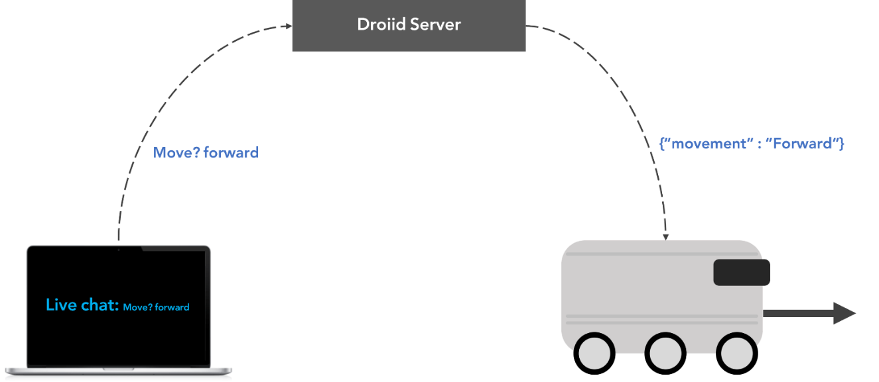

Figure 4 Droiid movement and commands

**2.8 THEORETICAL BACKGROUND AND ANALYSIS**

In this section, the iterative, creative, decision-making process in which the basic sciences, mathematics, and engineering sciences are applied to convert resources into solutions is to be demonstrated. A complete theoretical analysis of the proposed solution is to be given where equations, calculations, etc., are clearly explained before alternative solutions are suggested.

* 1. **Analyzing Alternative SOLUTIONs**

**2.9.1-Morphological chart**

|  |  |  |  |  |  |
| --- | --- | --- | --- | --- | --- |
| **Function** | **Means** | | | | |
| **1** | **2** | **3** | **4** | **5** |
| 1. Traversal of the campus | Wheels | Propellers | Continuous wheel track | Quadruped/Biped | Conveyer belt |
| 2. Carrying the package | Wagon | Carried Box | Pneumatic tubes |  |  |
| 3. Navigation | GPS | Predefined path | Pilotage [i] |  |  |
| 4. Maintain the safety of the package | Digital lock | Combination Lock | 2-step verification |  |  |
| **Feature** | **Means** | | | | |
| **1** | **2** | **3** | **4** | **5** |
| 1. Fast | Motors power | Mechanic | Lightweight |  |  |
| 2. Long battery life | Energy consumption | Capacity | Recharge time |  |  |

Table 2 Morphological Chart

[i] navigating by reference to visible landmarks

* **Alterative A:** Quadruped robot with a wagon attached to it, navigates using pilotage, the packages are secured using a 2-step verification system (2FA)
* **Alternative B**: Conveyer belt where the packages are put in a plastic box and placed on it, the conveyer belt spans the campus on a predefined path, the packages are secured using a combination lock.
* **Alternative C**: Ground robot that uses wheels to traverse the campus, the package is loaded on the robot (carried box), it navigates using GPS, the packages are secured using a Digital lock

Ideas from initial brainstorming:

* **Alternative D:** Robot Train
* **Alternative E:** Pneumatic System
* **Alternative F:** Drone delivery

# Alternative analysis

* 1. Ground Robot

A ground robot with a built-in storage cart uses four wheels to move between buildings within the university campus. The robot needs to be able move safely using obstacle avoidance techniques to avoid objects around it. It uses battery, to supply enough power for a complete back and forth trip. To be able to move between buildings, the ground robot needs a navigation algorithm to guide the robot through the whole trip.

**Pros:**

* Dynamic stop points
* Flexible pathfinding
* Doesn’t require special roads
* Moderate complexity

**Cons:**

* Requires obstacle avoidance algorithms
* Higher probability of getting stuck
* Easily tampered with
* Training phase is required

Movement

Batteries

Controller

Motors

Rear wheels

F

Kinetic ergy

Commands

Power

Heat

Sound



Figure 16 - Ground Robot’s glass box

Figure 5 – Ground robot Glass box

Cost analysis

|  |  |  |  |
| --- | --- | --- | --- |
| **ITEM** | Expected Price | Quantity | Total |
|  |
| Jetson nano | $75.00 | 1 | $75.00 |  |
| Stereo Camera Module Compatible with Jetson Nano | $45.00 | 1 | $45.00 |  |
| Motor driver | $12.00 | 4 | $48.00 |  |
| Platform | $100.00 | 1 | $100.00 |  |
| Battery | $20.00 | 1 | $20.00 |  |
| Wheels | $12.00 | 4 | $48.00 |  |
| Motors | $15.00 | 4 | $60.00 |  |
| Total cost |  |  | $336.00 |  |

Table 3 Cost analysis for ground robot

* 1. RoboDog

This alternative is a quadruped robot. It uses two front legs and two hind legs to move just like an animal would. Furthermore, it can traverse at acceptable speeds and carry a heavy load. This alternative can also walk on the campus and roads.

Pros:

1. Innovative
2. Can climb stairs
3. Can drag or carry the packages

Cons:

1. Complex

Table 4 Cost analysis for robodog

1. Easily tampered with (pushing, vandalizing, etc…).

|  |  |  |  |
| --- | --- | --- | --- |
| **ITEM** | Expected Price | Quantity | Total |
|  |
| Jetson nano | $75.00 | 1 | $75.00 |  |
| Stereo Camera Module Compatible with Jetson Nano | $45.00 | 1 | $45.00 |  |
| LIDAR sensor | $100.00 | 1 | $100.00 |  |
| Gyroscope sensor | $15.00 | 1 | $15.00 |  |
| Wagon | $60.00 | 1 | $60.00 |  |
| Battery | $20.00 | 1 | $20.00 |  |
| Artificial limbs (3D printed) | $40.00 | 2 | $80.00 |  |
| Servo motors | $20.00 | 8 | $160.00 |  |
| Total cost |  |  | $555.00 |  |



Figure 6– RoboDog’s Glass box

1. Robot train tracks

To be able to use a mini train within campus, we need train tracks that connect the buildings we want to deliver to and from. By having different stops at different faculty buildings, and smart train junctions that can save time by switching to shorter routes the user can drop off the packages at 1 of the stops and then the receiver would take the package at the stop nearest to him/her.

Pros

* Eliminates the need for navigation algorithms.
* If pedestrians avoid the tracks, no need for obstacle avoidance.
* Can be fast

Cons

* Requires train tracks to function.
* Sub-optimal routes
* Limited to set of stops



Heat

Batteries

Controller

Train Tracks

Motors

Train

Power

Kinetic energy

Information

Power

Deliver packages

Sound

Figure 7 – Robot traintracks Glass box

Cost analysis

|  |  |  |  |
| --- | --- | --- | --- |
| **ITEM** | Expected Price | Quantity | Total |
|  |
| Arduino uno | $40.00 | 1 | $40.00 |  |
| Wagon | $60.00 | 3 | $180.00 |  |
| Battery | $20.00 | 1 | $20.00 |  |
| Traction motor | $450.00 | 1 | $450.00 |  |
| Total cost |  |  | $690.00 |  |

Table 5 robot train tracks cost analysis

# Choosing Baseline Design

|  |  |  |  |  |  |  |
| --- | --- | --- | --- | --- | --- | --- |
| Musts/Alternatives | A: Quadruped Robot | B: Conveyer Belt | C: Ground Robot | D: Robot Train | E: Pneumatic tube system | F: Drone |
| The ability to move within 2 km range of the Engineering building | GO |  | GO | GO |  |  |
| Ensures the safety of the packages. | GO | GO | GO | GO | GO | GO |
| Includes a storage unit for the shipments. | GO | GO | GO | GO | GO | GO |
| Tamper proof electronic components | GO | GO | GO | GO | GO | GO |
| Made from durable material. | GO | GO | GO | GO | GO | GO |
| Operate within 5 km/h. | GO | NO GO | GO | GO | GO | GO |
| Can carry weight within (80kg). | GO |  | GO | GO | NO GO | NO GO |
| Constraints |  |  |  |  |  |  |
| The cost of the project must not exceed 5000 SAR. | GO |  | GO | GO |  |  |
| Project must be completed before the end of Term-2. | GO |  | GO | GO |  |  |
| Causes no harm to the surroundings. | GO |  | GO | GO |  |  |
| Battery life lasts for at least one complete trip (2 km). | GO |  | GO | GO |  |  |
| Guarantees the privacy of the packages. | GO |  | GO | GO |  |  |
| The artifact should withstand normal heat (36° C) for the duration of the trip (2 km) | GO |  | GO | GO |  |  |

Table 6 KTDA table

After analyzing the alternatives, we chose the **Ground Robot** to be our baseline design. Due to it having the lowest cost, balanced complexity, and the availability of the parts. We modeled our idea using SolidWorks to be able to imagine our baseline design.



Figure 6 Solidworks model

**2.10 maturing baseline design**

To further improve our base model, we started thinking of things we could change. We thought of reusing a hoverboard instead of buying the different motors and motor drivers. Hoverboards contain powerful motors that could carry people (~100 kg) which makes the design sturdier. Furthermore, wheel encoders are included in the hoverboard eliminating the need to buy them. In addition to that, the hoverboards have a recharging capability that is simple to use. We also thought of adding ventilation slits to the wagon to improve thermal dissipation. In addition to that, one idea was to add a hole in the wagon for cable management to eliminate the possibility of unwanted friction of the wires with the ground.

**Chapter – 3 PRODUCT BASELINE DESIGN**

**3.1 Block diagram**

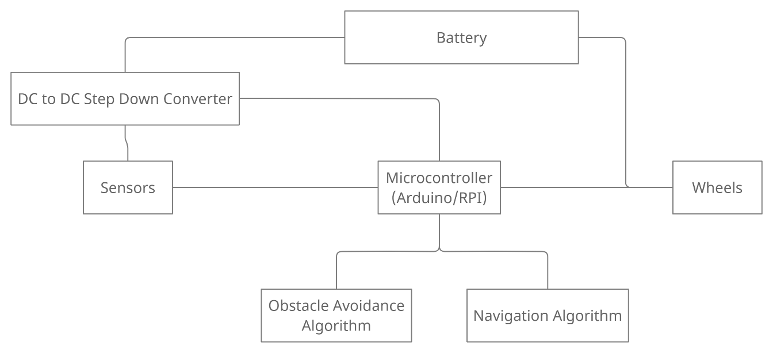

Figure 7 Block Diagram

**3.2 System descritpion**

***3.2.1 Circuit schematics***

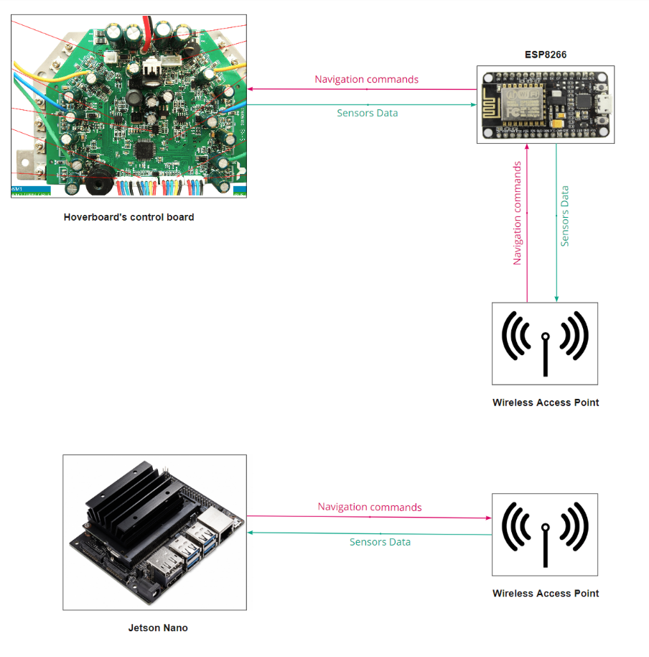The green arrows represent the flow of data from the sensors. As shown in the figure the sensors data flow from the hoverboard to a Wi-Fi module and then to the Jetson Nano. The data is then processed by the Jetson nano and using the algorithms for navigation and obstacle avoidance it sends the commands though the chain to the hoverboard

Figure 8 Circuit Schematics

***3.2.2 Circuit component specifications***

|  |  |
| --- | --- |
| **Component** | **Specifications** |
| **Jetson Nano** | **Manufacturer:** Nvidia  **GPU:** 128-core NVIDIA Maxwell  **CPU:** Quad-core ARM® A57  **Memory:** 2 GB 64-bit  **Module Size:** 70mm x 45mm |
| **NodeMCU ESP8266** | **Microcontroller:** ESP-8266 32-bit  **Module Size:** 49mm x 26mm  **Clock speed:** 80 MHz  **Operating Voltage:** 3.3V  **Input voltage:** 4.5V-10V  **SRAM:** 4 MB / 64 KB  **Digital Pins:** 11  **Analog Pins:** 1  **Built-in Wi-Fi:** 802.11 b/g/n  **Temperature range:** -40C - 125C |
| **IMX219-83 8MP 3D Stereo Camera Module** | **Megapixels:** 8 Megapixels  **Resolution:** 3280 × 2464 (per camera)  **Dimensions:** 24mm × 85mm  **Gyroscope Operating Current:** 1.23mA  **Angle of View:** 83/73/50 degree (diagonal/horizontal/vertical) |
| **dc-to-dc convertor 12v to 5v** | **Manufacturer:** Chuanguifa  **Type:** step down dc-to-dc convertor  **Input voltage:** 12V  **Output Voltage:** 5V  **Output current:**3A  **Output power:**15W  **Efficiency:** ＞96%  **Operating temperature:** (-40°, 80°)  **Size:** 45x26x12 (mm) |
| **Rechargeable battery** | **Voltage:** 36 V  **Discharge Current:** 75A  **Dimensions:** 101mm x 90mm x 70mm  **Weight:** 1.62 Kg  **Internal Resistance at 1KHz:** 34 mΩ |
| **Motors** | **Manufacturer:** huhu  **Speed:** 100 RPM  **Operating voltage:** 36 volts  **Torque:** 10 Kg.cm  **Weight:** 158.75 g |

Table 7 Circuit specifications

***3.2.3 Flowcharts for software blocks***

## **Navigation Flow Chart**

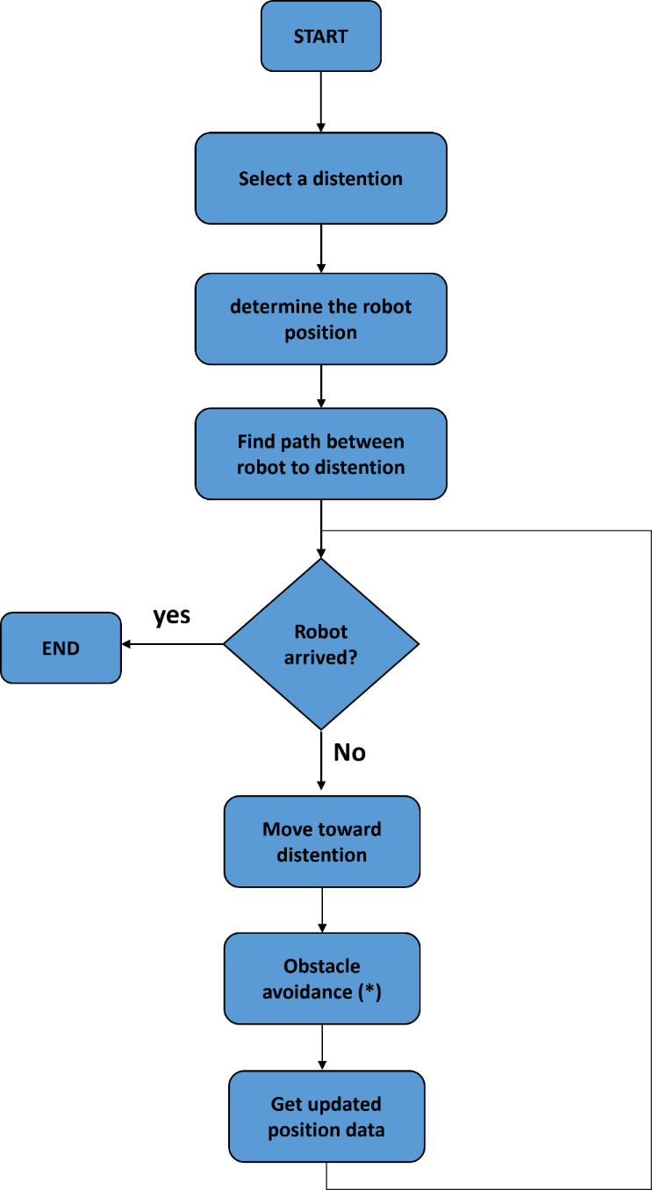

Figure 9 Navigation flowchart

## **Obstacle avoidance flow chart**

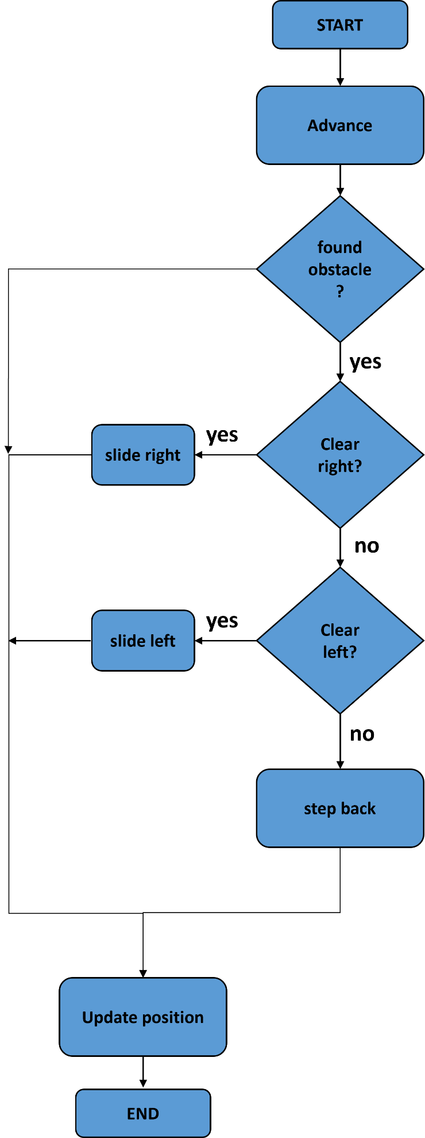

Figure 10 Obstacle avoidance flowchart

***3.2.4 Mechanical specifications of the case***

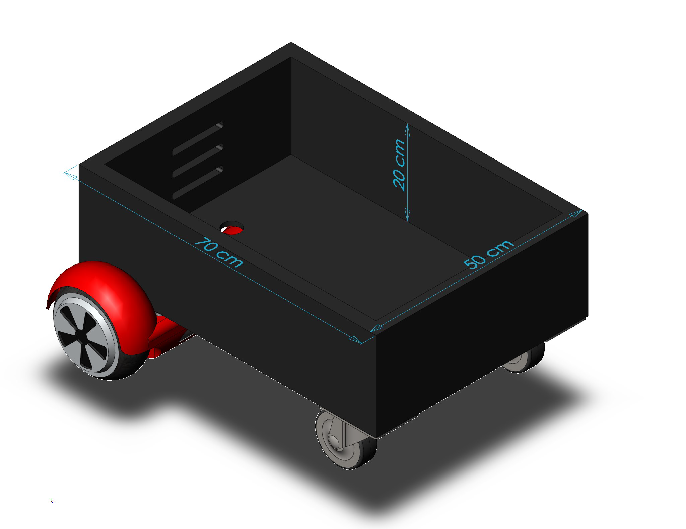The figure below shows a SolidWorks model of the cart after adding the changes discussed in maturing the baseline design. The cart is a rectangular prism with the dimensions (L×W×H) (70×50×20 cm)

Figure 11 Solidworks model with hoverboard

***3.2.5 Possible aesthetics***

Aesthetics are an important part to make the user feel more connected to the robot. There are two main aesthetical changes that would be beautiful if applied to the artifact. First, stickers that can be applied to the robot with the logo of KAU and Engineering Faculty. These stickers can be applied to the sides of the platform to showcase that the robot is from the students of the faculty. This in turn may help the users feel a sense of home.

Another beautification idea is painting the robot white in color. This can allow the robot to be seen clearly from far away which can help people recognize the robot. Even though the robot might not need this, it helps promote a beauty aspect in robots.



Figure 12 KAU Icons

***3.2.6 Input/output specifications***

An AC input power source of 220Vac with 60Hz frequency, single phase is needed to supply the battery with charging power. Max input current is 2A current with max power consumption of 440W.

***3.2.7 Operating Instructions***

Operation of the robot is very simple; any layman can use it without issue.

1. Locate the robot within a stop point.
2. Place shipment/package inside the luggage compartment.
3. Open the robot UI using any smart device.
4. Enter destination for the shipment and receiver details.
5. Enter lock **#** for security.
6. Press Start.
7. Wait for confirmation from receiver. (done)

**3.3 Simulation results**

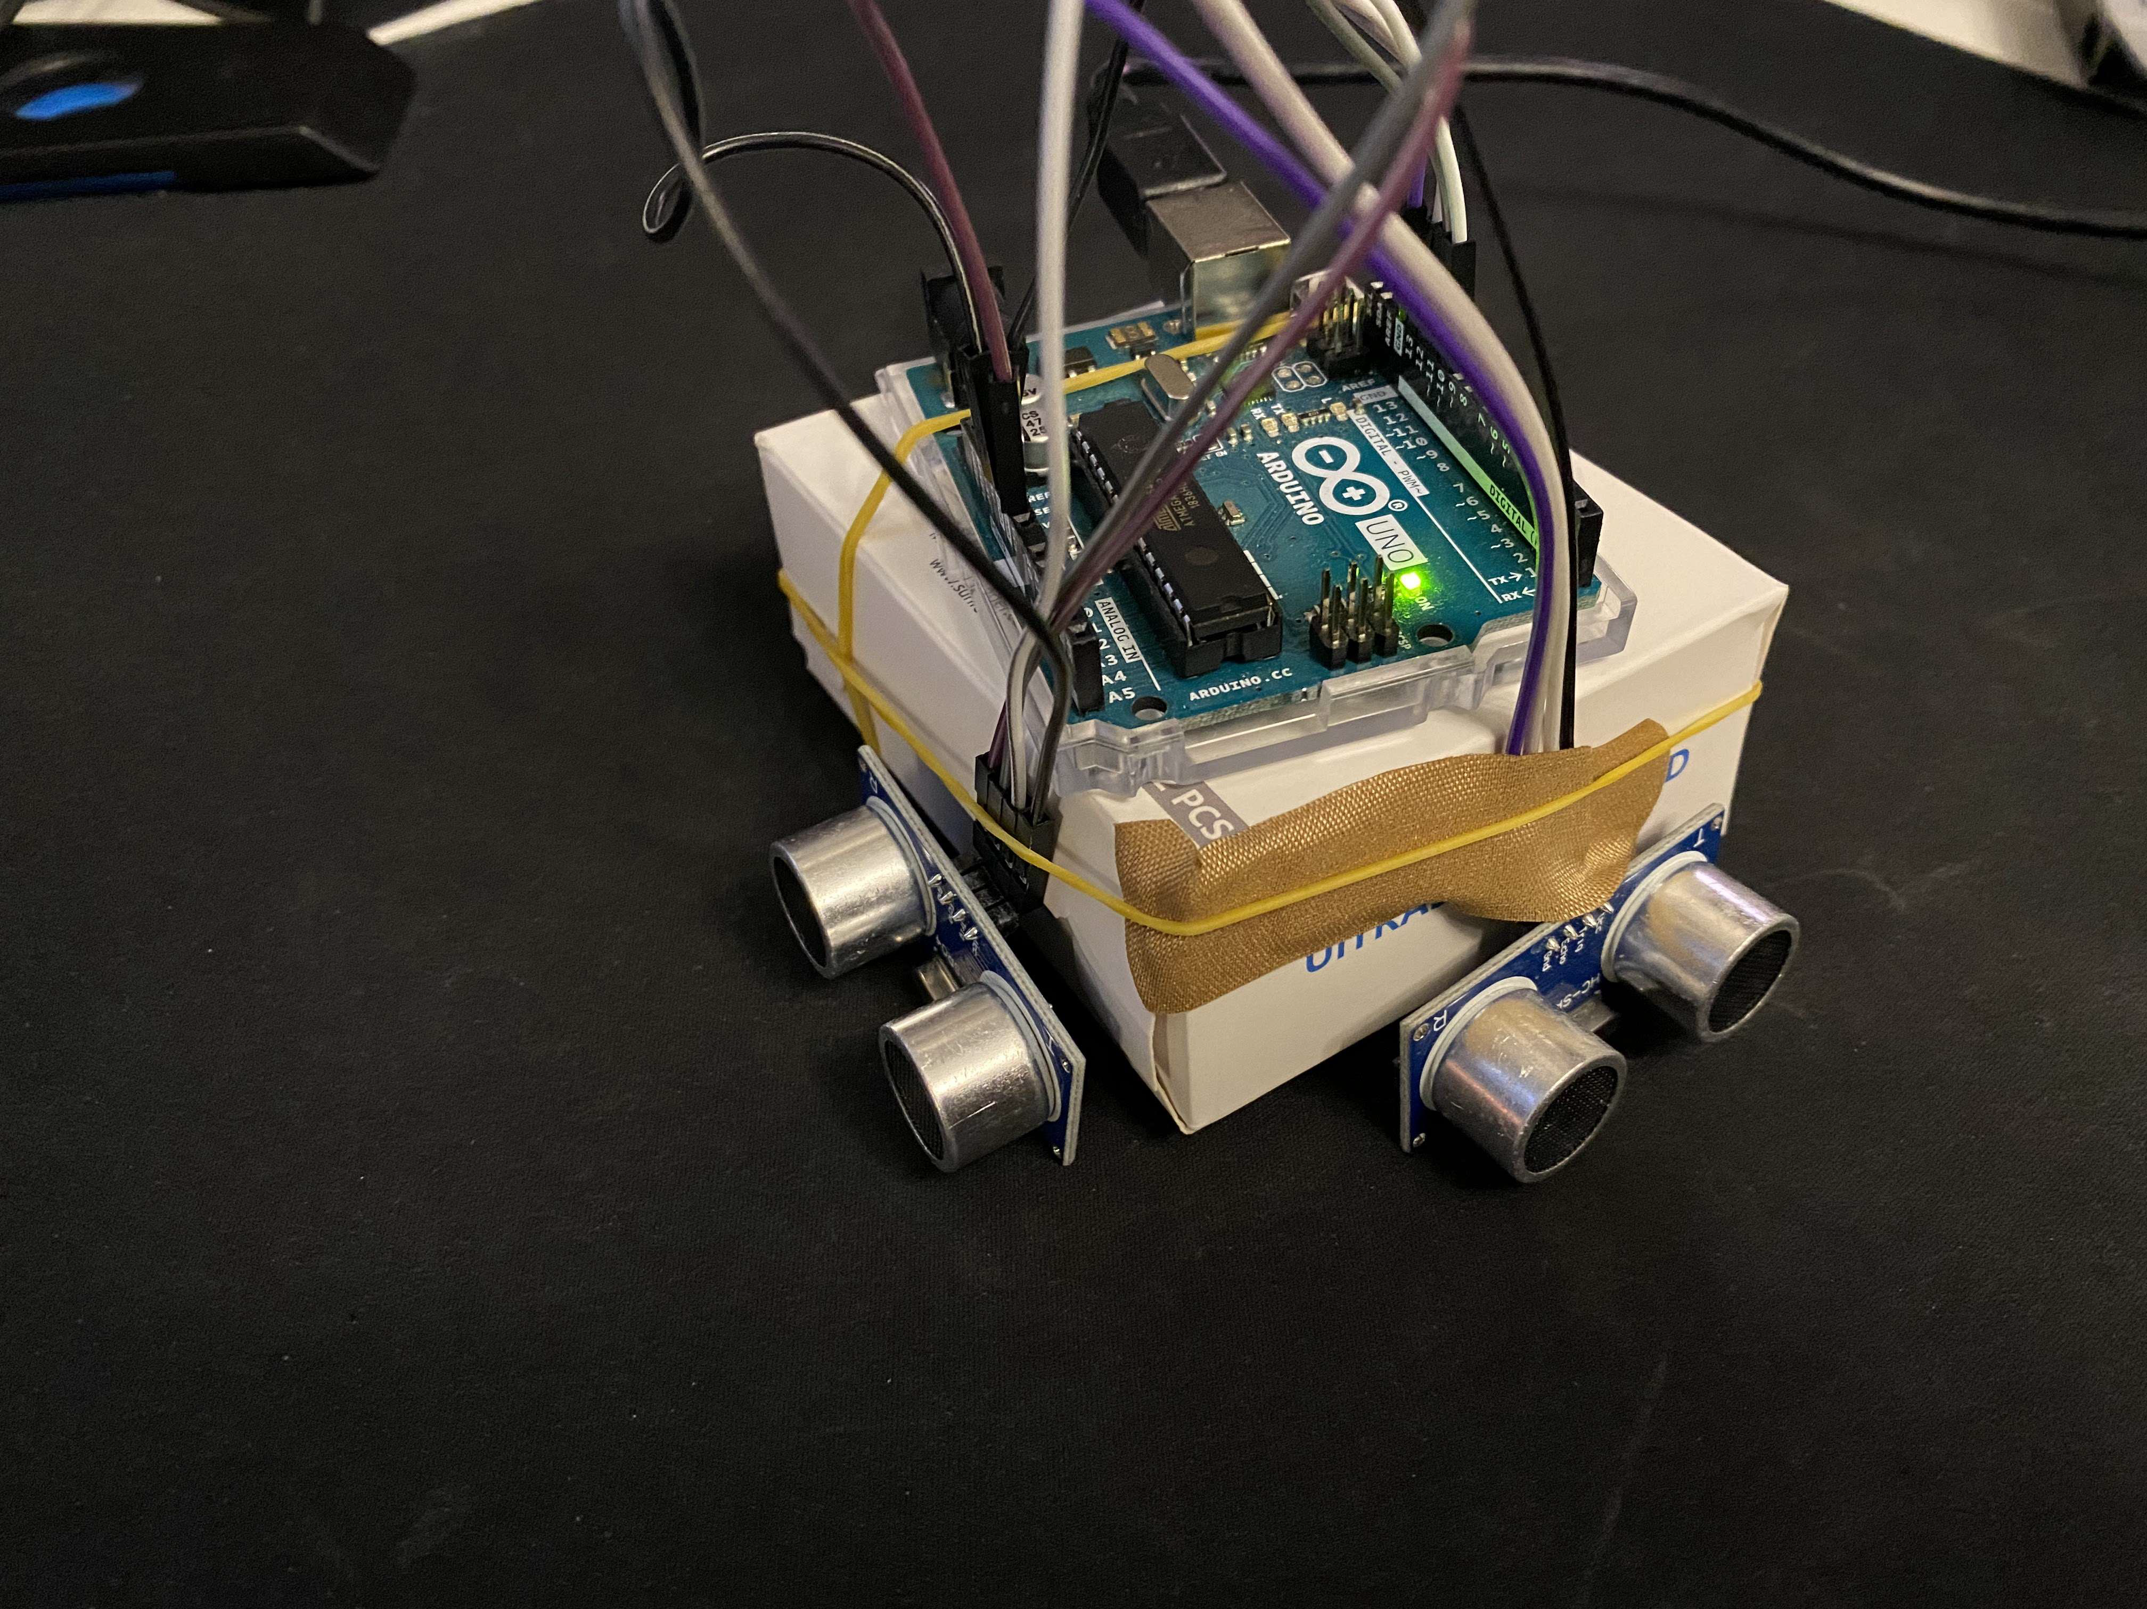For simulation we made a localization program using MATLAB. We connected the Arduino to MATLAB, and we used ultrasonic sensors to measure distance and find out the location of the robot relative to the “walls” or in our case, the box’s boundaries.

Figure 13 Prototype of the senors

Figure 14 - Localization prototype

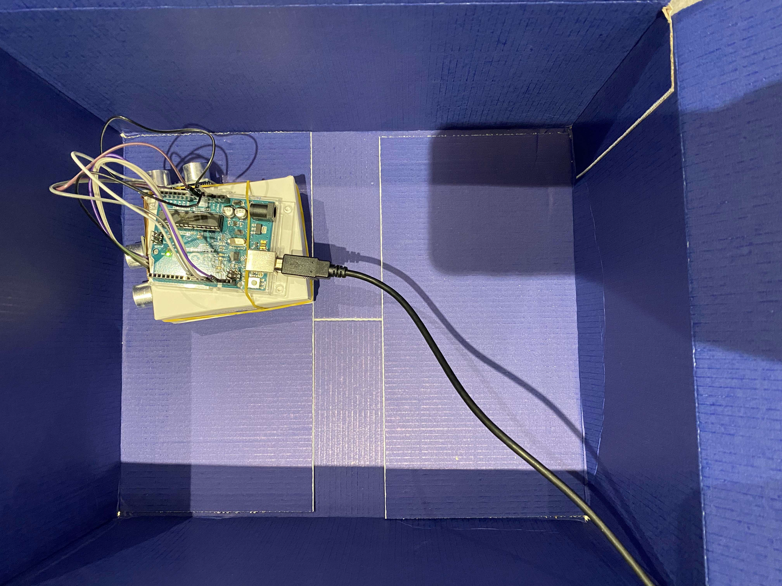The prototype uses 2 ultrasonic sensors 1 for each coordinate in the xy-plane.

Figure 15 Example of sensors usage

We placed the prototype in a box and started the program. Giving us the result shown in the figure below.

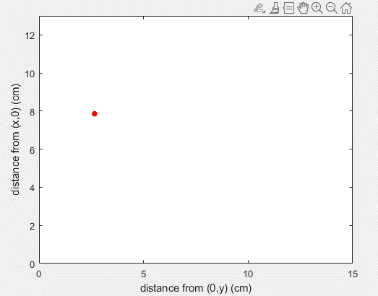The red dot represents the prototype, and the boundaries of the plot represent the walls of the box. The plot is dynamic, meaning that the red dot moves with the movement of the prototype. It is not just a snapshot of the location at a particular moment.

Figure 16 Matlab graph showing distances

**Chapter – 4 Preliminary Evaluation of Baseline design**

**4.1 Technical Aspects**

Perhaps the most critical musts for our project are the ability to carry a weight within **80 kg** and that the artifact must be able to operate within **5 km/h**. To be able to satisfy those conditions we need powerful motors. Different hoverboards might have slightly different specifications but generally, the motors have a power of about **350 W** at **36 V** and can speed at speeds of up to **700 rpm** at higher voltages. For the speed requirement, hoverboards can operate at about **9.6 km/h** to **16 km/h** in faster models which is more than enough in our case. The wheels used in hoverboards have a diameter of about **15-25** **cm**. [1]

**4.2 Cost Analysis**

|  |  |  |  |
| --- | --- | --- | --- |
| **ITEM** | Expected Price | Quantity | Total |
|  |
| Jetson nano | $75.00 | 1 | $75.00 |  |
| Stereo Camera Module Compatible with Jetson Nano | $45.00 | 1 | $45.00 |  |
| motor driver | $12.00 | 2 | $24.00 |  |
| Platform | $100.00 | 1 | $100.00 |  |
| battery | $20.00 | 1 | $20.00 |  |
| Wheels | $12.00 | 4 | $48.00 |  |
| Motors | $25.00 | 2 | $50.00 |  |
| Arduino uno | $20.00 | 1 | $25.00 |  |
| GPS | $27.00 | 1 | $27.00 |  |
| Wifi adapter | $5.00 | 1 | $5.00 |  |
| Total cost |  |  | $419.00 |  |

Table 8 Updated cost analysis

**4.3 Environmental impact**

It is known for years that our vehicles produce harm gases to our environment. However, we cannot refrain from using them. The only thing we can do, is to reduce our usage and to eliminate unnecessary trips. One service our product provides is to reduce the need of using a car in delivering shipments within the campus.

Although our product does not produce green gases, it still has some impacts on the environment. For instance, the baseline design uses a lead acid rechargeable battery which could cause potential threat to people and to the environment if not properly discarded. However, we encourage having a facility that recycles dead batteries to reduce their potential impact on the environment by extract the lead.

In the baseline design, although we could have included other power options that may produce harm gases to our environment we preferred not to, for the sake of our environment. Another way of visualizing the big picture is to consider that the product reduces the need of having duplicated versions of certain things (e.g., textbooks, papers, plastic tools) by allowing these gadgets to be easily transferred from building to another. Which expected to play good for our environment.

**4.4 impact on society**

## **Stereo camera**

Although using a stereo camera can facilitate obstacle avoidance and navigation, some people might be opposed to it due to privacy concerns. People might be bothered by seeing a robot equipped with a camera roaming around campus thinking that they are being recorded. To mitigate that effect, we could put notes that state that no camera footage would be published anywhere unless necessary by law.

## **Motors**

Motors are crucial in any type of robot that is expected to move. Nevertheless, it might cause some disturbance to students and faculty members due to the noise. Although according to a survey done as a part of a research project, most people are only mildly annoyed by electric scooter noise in comparison to combustion scooters.

**4.5 Global Impact**

Robotics is a very interesting subject; the ever-growing revolution of robots is rapidly increasing. Technological advancements in engineering, automation, AI and machine learning will revolutionize the capabilities of robots and they will take over tasks that human laborers use to do.

The robotics industry growth will boost the economy and productivity. Furthermore, it will lead to many new jobs that are yet to exist. Consequently, around 20 million manufacturing jobs may be lost by 2030 to robots. However, robots can be much more efficient than humans at these jobs and can provide better outcomes. Moreover, humans can monitor these robots and make sure the job gets done well.

The effects of job losses have a big variance between countries/regions. In lower skilled regions, the robots can cause twice the unemployment rate by taking up many jobs. This in turn can cause economic and social distress where the regions are already under big issues.

# References

[1] J. Waykule, "Smart Drone Delivery System", *https://www.researchgate.net/*, 2020. [Online]. Available: https://www.researchgate.net/publication/344513432_Smart_Drone_Delivery_System. [Accessed: 28- Sep- 2021]

[2] Source: Adapted from [1]

[3] "Prototype design of medical round supporting robot “Terapio”", *Ieeexplore.ieee.org*, 2021. [Online]. Available: https://ieeexplore.ieee.org/abstract/document/7139274. [Accessed: 28- Sep- 2021]

[4] Source: Adapted from [3].

[5] D. Dhabale, "Design and Development of Autonomous Delivery Robot", *Arxiv.org*, 2021. [Online]. Available: https://arxiv.org/pdf/2103.09229.pdf. [Accessed: 28- Sep- 2021]

[6] E. Kouao, "This Raspberry Pi Delivery Robot is Controlled by Live Stream Chat", *Tom's Hardware*, 2021. [Online]. Available: https://www.tomshardware.com/news/raspberry-pi-delivery-robot-droiid. [Accessed: 28- Sep- 2021]

[7]"How Robots Change the World - What automation really means for jobs, productivity and regions", Oxford Economics, 2021. [Online]. Available: https://www.oxfordeconomics.com/recent-releases/how-robots-change-the-world. [Accessed: 22- Nov- 2021]

[8] “Battery Safety Testing and Certification | UL.” https://www.ul.com/services/battery-safety-testing (accessed Oct. 24, 2021).

# APPENDIX A: Ethical case study

**بسم الله الرحمن الرحيم**

King Abdulaziz University - Faculty of Engineering – EE-499

**Senior Design Project**

**Report#3**

Ethical Case Study

|  |  |
| --- | --- |
| **Name** | **ID** |
| Muhannad Saeed Alghamdi | **1846525** |

Contents

Saudi Council Code of Ethics 2

Introduction 3

Engineering Dilemma 4

Discussion 4

A) First Scenario 4

B) Second Scenario 4

C) Third Scenario 5

D) Fourth Scenario 5

Ethical Discussion 5

Conclusion 5

References 5

# Saudi Council Code of Ethics

The engineering profession and the services provided by engineers depends significantly on the progress of civilization and the protection and harnessing of natural resources to serve the community and increase the standard of living. Thus, it becomes necessary for engineers to provide their professional services according to ethical standards and rules observing honesty, truthfulness and perfection.

Since the Saudi Council of Engineers is concerned with and aims to promote the profession of engineering and all that would develop and raise the level of the profession and its practitioners under its law promulgated by the Royal Decree No. 36 on 26/09/1423H, and since its vision is to "sophisticate the profession of engineering and enable engineers and institutions of engineering to reach optimal solutions, to improve performance level, and to encourage creativity and innovation to achieve a prestigious international position," the Council has opined to present these rules to engineers and technicians in various positions to serve as professional rules determining proper professional dealing among themselves and with others to serve society.

Since justice, integrity, honesty, truthfulness, keeping one's word, never exposing secrets, mutual advice, mastery of work, and getting away from hurting others are in their entirety the morals and values advocated by Islam that urges to stick to them and to abide by applying them in everyday life, the Saudi Council of Engineers has taken into account these foundations, principles and values when preparing the rules and ethics governing the practice of the profession. Thus, all engineers should abide by these rules in all their professional practices in accordance with the Engineer Agreement signed in this regard. The General Rules of the Saudi Council Code of Ethics (Code of Ethics, 2021):

**Rule One:** Every engineer should build her/his professional reputation based on efficiency and proficiency of her/his services, and away from unfair competition with others.

**Rule Two:** Every engineer should seek to develop her/his personal abilities and efficiency, and should also provide professional development opportunities for engineers and technicians working under his supervision.

**Rule Three:** Every engineer should be committed to promoting the fundamental values and principles of the ethics of the engineering profession and should plant them within society. Regarding her/his conduct, every engineer should be s in ways that support and enhance the prestige and dignity of the profession and the secretariat of the locally and globally.

**Rule Four:** Regarding professional issues, Every engineer shall act as a careful agent to the employer, and shall avoid any conflict of interests.

**Rule Five:** When submitting her/his ideas, views and decisions, every engineer should be keen to be objective and honest and confined to her/his field of expertise and professional experience.

**Rule Six:** When providing professional services, every engineer seeks to apply the highest standards of safety and environmental protection in order to achieve the public interest of individuals and society.

# Introduction

Every engineer could be in a position where a decision must be taken. The different possible decision could have some ethics violations, an engineer must consider the different scenarios and choose the best ethical decision based on the used code of ethics. In this report we will discuss an engineering dilemma with some different possible scenarios, discussing the potential consequences of each scenario and taking the best decision for this engineering dilemma.

# Engineering Dilemma

Mohammad works as an industrial engineer in a construction company. The company has a constructional project, where the company decided to find a local contractor. The company formed a team to receive the bids and study the different bid offers. Mohammad was requested to lead the team. However, Mohammad's friend Ahmad who works on the same department with Muhammad and who was not selected in the team hinted to Muhammad that he wants to know the bids details. However, Mohammad ignored those hints until Ahmad asked him directly about the bids details so he can leak it to his brother who works as a contractor in the construction field. Now, Mohammad is in a position where he has to take an action, there are different possible scenarios for the actions Mohammad could take, we will discuss each possible scenario and its possible consequences, there are three main points could affect Mohammad's decision we will consider them in each scenario:

1. Mohammad and Ahmad are friends for more than 10 years.
2. Mohammad knows the details of each bid, as he leads the responsible team.
3. Mohammad is a professional engineer known for years with his integrity
4. Ahmad is pushing Mohammad seriously to give the details of the bids and threaten to end their friendship
5. Ahmad offered to share some of the profit with Mohammad if his brother won the tender

# Discussion

Muhammad now is in a difficult situation where he has to decide what to do. He could be in the safe side and take an ethical decision sacrificing his ten tears friendship with Ahmed. Or he could take an unethical decision so save that friendship and to profit from the wining contractor. For this we will discuss some different scenarios Mohammad could take and which rule is violated in each.

## First Scenario

In the first scenario Mohammad could just simply leak the details to Ahmad to save their friendship and also to get the promised profit if Ahmad's brother won the tender. Although this could be an easy decision to take but however, the consequences for this decision are more harmful. This scenario includes a conflict of interest as rule four (4.7) states, Mohammad seeks to get a profit by helping one contractor instead of aiming to choose the best bid for the good of the company. Also Leaking the bids details considered a violation of rule four (4.2) as Ahmad requested the bids details which is considered confidential information and disclosing such information without an approval is considered a violation. Another violation is clearly illustrated by the profit received in case Ahmad's brother won the tender, this is a clear violation of the rule four (4.8). Although Mohammad could save his friendship with Ahmad and get some profit but the consequences of violating the previous rules are unneglectable.

## Second Scenario

Mohammad could be afraid of leaking such confidential information, so he decides to create a position in the team to include Ahmad in the responsible team, and then Ahmad will get the details himself as he as now a member of the team and leak the bids details to his brother, so both could be happy as Mohammad saved their friendship, and Ahmad helped his brother to win the tender. However, included Ahmad in the team for that purpose is considered a violation of rule four (4.3) as Ahmad was include not for his good performance but for another purpose, while there could another engineer who deserves this position more than Ahamad. Also, this behavior violates rule three (3.5) as Mohammad participated to cover up the leaking action done by Ahmad.

## Third Scenario

In the third scenario, Mohammad could just refuse to disclose such information but, to satisfy Ahmad's need he will try affect his team judgment by underrating other bids and recommend the offer coming from Ahmad's brother. As these judgment and discussions Mohamad uses to convince his team members are not scientific and based on personal interests. Then this is a clear violation of rule five (5.1) as the decision making was based on satisfying Ahmad's need to make his brother bid the one accepted by the company instead of selecting the best bid based on the engineering fundamentals.

## Fourth Scenario

One Scenario happens if Mohammad immediately refused Ahmad offer, and reported that to the responsible department so they can take any required actions to save the future of the company. Although this decision may lead to ending a friendship that lasted for more than ten years, but it is an ethical decision and the most recommended action As there is a commitment to the code of ethics, and to our Islamic learnings. On the other hand, Mohammad and Ahmad relation as friends could be affected as Ahmad threaten. But however, this could not be as harmful as Mohammad losing his integrity and ethics in order to satisfy Ahmad needs in each time.

# Ethical Discussion

As we have seen, the fourth scenario could be the best scenario to have as Mohammad will not make any unethical decision that could harm him or anyone else. However, in many cases it could be difficult to choose from the different possible actions. As in this case, the friendship was a ten years old friendship which could be difficult to sacrifice, but if we considered the other options, their consequences are more harmful than ignoring Ahmad needs and reporting it to the responsible department. But however, if Mohammad chose an unethical behavior just to save their friendship, then in addition to the ethical violation, he saved himself from having a poisonous friendship.

# Conclusion

In this report, we have discussed a study case where an engineer has to make a decision, the different decision the engineer takes have different consequences some could be more ethical than other, and some may harm the engineer career and the society, and we consider them as unethical decisions. We also discussed the possible scenarios for the case study, and considered the best available decision where no ethical violation occurred.

# References

*Code of Ethics*. (2021). Retrieved from Saudi Council of Engineering: https://www.saudieng.sa/English/EngineerCorner/Pages/CharterEngineer.aspx

**EE-499**

**Name: Sulaiman Abbas**

**College ID: 1845862**

**Team#:3**

**Member#:2**

**Ethical Case Study**

**Saudi Council of Engineers (SCE) [1]**

**General rules:**

**Rule One:** Every engineer should build her/his professional reputation based on efficiency and proficiency of her/his services, and away from unfair competition with others.

**Rule Two:** Every engineer should seek to develop her/his personal abilities and efficiency, and should also provide professional development opportunities for engineers and technicians working under his supervision.

**Rule Three:** Every engineer should be committed to promoting the fundamental values and principles of the ethics of the engineering profession and should plant them within society. Regarding her/his conduct, every engineer should be in ways that support and enhance the prestige and dignity of the profession and the secretariat of the locally and globally.

**Rule Four:** Regarding professional issues, every engineer shall act as a careful agent to the employer, and shall avoid any conflict of interests.

**Rule Five:** When submitting her/his ideas, views and decisions, every engineer should be keen to be objective and honest and confined to her/his field of expertise and professional experience.

**Rule Six:** When providing professional services, every engineer seeks to apply the highest standards of safety and environmental protection in order to achieve the public interest of individuals and society.

**Case:** Reassignment to another location (adapted from NSPE Case No. 16-9) [2]

Mohammed works for Engineering Solutions, an engineering firm owned by Ali. Engineering Solutions does business in several cities but is headquartered in Riyadh. Engineering Solutions has a policy to not terminate an employee unless they provide the employee with at least 90 days of written notice of termination. Due to short-hand issues confronting Engineering Solutions, Ali decides to reassign some of its employees, including Mohammed, to Jeddah away from Engineering Solutions headquarters in Riyadh where Mohammed has been working. As a result, Mohammed will need to relocate with his family. Engineering Solutions advises reassigned employees that they have one week to decide and their failure to accept reassignment would constitute their resignation of their position with Engineering Solutions. Mohammed is unable to relocate due to family issues and claims that, as a practical matter, Ali’s decision to unilaterally reassign Mohammed to another location constitutes a violation of Engineering Solutions’ written notice policy of providing at least 90 days of “written notice of termination,” and therefore is unethical.

**Discussion**

The case at hand showcases a situation where two engineers and a company are faced with an issue of re-location. The company has its policy about re-location in which it must notify an engineer within 90 days. Furthermore, the company gave Mohammed an ultimatum of moving within a week or getting fired/resigned.

**Scenario 1:** Mohammed accepts to re-locate within 1 week of receiving the ultimatum, he and his family have to move to Jeddah. With this option Ali violates **Rule two** of the SCE Ethics code.

**Scenario 2:** Mohammed does not respond to the ultimatum and gets fired from Engineering Solutions. With this he violates **Rule three** of the SCE Ethics code.

**Scenario 3:** Mohammed accepts the re-location ultimatum and relocates with his family to Jeddah. In parallel, Ali reimburses Mohammed with a raise to his paycheck.

**Scenario 4:** Engineering solutions, owned by Ali, sticks to their policy and allows the engineers to reply within 90 days and manages the short-hand issues with temporary solutions.

In my opinion, the situation is tricky. Both parties need each other and a solution must be found. To determine, Scenario 1 is unethical in the sense that Ali is not being professional with those working under his supervision. Scenario 2 is really bad; Mohammed is not behaving with the principles of engineers and should not happen. Scenario 3 is some-what acceptable but Mohammed’s family would suffer by moving to a new city. Finally, I believe **Scenario 4** is the best outcome, it shows that the company sticks to its policy and would not harm its engineers. Furthermore, since the issue is not financial but short-handed, the company can manage until their engineers make a choice.

**References:**

[1]"Engineer Agreement", Saudieng.sa, 2021. [Online]. Available: https://www.saudieng.sa/English/EngineerCorner/Pages/CharterEngineer.aspx. [Accessed: 17- Nov- 2021]  
[2]"Employment—Reassignment to Another Location | National Society of Professional Engineers", Nspe.org, 2021. [Online]. Available: https://www.nspe.org/resources/ethics/ethics-resources/board-ethical-review-cases/employment-reassignment-another. [Accessed: 17- Nov- 2021]



Report 3 - Ethical Case Study

-Fall 2021-

Course: EE499

Students: Wael Aldhaheri – 1846978

Supervised by: Dr. Mohammed Bilal

1. Introduction

Engineers face situations they must choose between right and wrong. But sometimes it’s not very clear-cut and it’s hard to discern between the choices. There are three main things that affect the decisions of engineers: Morals, Ethics, Law. Morals are usually internal, and they differ from a person to another. Ethics and laws usually come from the external world. Laws are set by governments and ethics are usually set by professional societies of each profession. In this report the focus will be mainly on ethics.

1. Saudi Code of Ethics

According to the **Saudi code of ethics** an engineer shall follow these six general laws:

**Rule One:** “Every engineer should build her/his professional reputation based on efficiency and proficiency of her/his services, and away from unfair competition with others.”

**Rule Two:** “Every engineer should seek to develop her/his personal abilities and efficiency and should also provide professional development opportunities for engineers and technicians working under his supervision.”

**Rule Three:** “Every engineer should be committed to promoting the fundamental values and principles of the ethics of the engineering profession and should plant them within society. Regarding her/his conduct, every engineer should be s in ways that support and enhance the prestige and dignity of the profession and the secretariat of the locally and globally.”

**Rule Four:** “Regarding professional issues, every engineer shall act as a careful agent to the employer and shall avoid any conflict of interests.”

**Rule Five:** “When submitting her/his ideas, views and decisions, every engineer should be keen to be objective and honest and confined to her/his field of expertise and professional experience.”

**Rule Six:** “When providing professional services, every engineer seeks to apply the highest standards of safety and environmental protection in order to achieve the public interest of individuals and society.”[1]

1. Case Study
   1. Engineering Dilemma

**Fahad** is a clinical engineer working in a hospital in Saudi Arabia. The hospital has a rule that if anybody makes a mistake or even almost made a mistake, they should report it themselves and they would be treated more leniently. The hospital also has a system that automatically uploads ECG recordings to the hospital information system allowing the doctors to view them easily. A doctor requested from the nurse to take an ECG recording for one of the patients **Saeed**. After a few hours Saeed passed away due to a heart disease that would have been treatable if caught early but the doctor never received the ECG recording. At first, the administration thought that the nurse didn’t take an ECG recording and she was at fault. However, **Fahad** investigated the ECG device and found out that the CMOS battery has failed, and the date and time reset causing the ECG recording to appear in the system as something that was recorded years prior.

* 1. Case Analysis

In this case **Fahad** needs to decide, whether to report the device problem and prevent that mistake from happening again or to stay silent and the nurse might be wrongfully punished. People lives are at stake and **Fahad** needs to choose the ethical decision. These are the possible scenarios:

**1. Fahad does nothing:** Fahad could stay silent and not report the problem with the CMOS battery. Which would endanger lives because that failure could happen again, and another person might be harmed because of the same mistake. In addition to that the nurse might be wrongfully punished. This decision would be unethical and Fahad wouldn’t be acting in compliance with **Rule Six:** “When providing professional services, every engineer seeks to apply the highest standards of safety and environmental protection in order to achieve the public interest of individuals and society.”[1]

**2. Fahad fixes the device but doesn’t report:** Fahad could also fix the ECG device but doesn’t report the problem to the administration. This would be a band aid solution that only temporarily solve the problem but doesn’t resolve the underlying issue that the CMOS batteries need to be replaced periodically. Although this is marginally better than the first scenario this still violates **Rule Six**

**3. Fahad fixes the device and reports the problem:** This would be the best solution; Fahad fixes the device and also reports the problem to administration so that they can come up with a preventive plan to stop this from happening again.

1. Final Ethical Discussion

Based on the rules of the Saudi code of ethics, **scenario 3** would be the best one. Because Fahad would be helping in achieving what is best for the patients and their safety.

1. References

[1] “Engineer Agreement.” https://www.saudieng.sa/English/EngineerCorner/Pages/CharterEngineer.aspx (accessed Oct. 05, 2020).